**Smart Agriculture: Deep Learning for Detecting Plants Disease Through Imaging**

**Faria Khan1, Vinit Poojary1, Aishwarya Shirsat1**

***1. Nilkamal School of Mathematics, Applied Statistics & Analytics, NMIMS***

Mentor: Dr. Yogesh Naik

# **Abstract**

Plants play a crucial role in global food production, but various environmental factors contribute to the spread of diseases, leading to significant yield losses. Accurate and timely detection of plant diseases is essential for ensuring food security. Traditional detection methods rely on manual inspection, which is labor-intensive and requires expert knowledge, limiting scalability. Deep learning has emerged as a powerful tool for automating plant disease detection through image-based analysis. In this study, we evaluate the performance of three state-of-the-art **Convolutional Neural Networks (CNNs)**—Xception, Inception-v3, and VGG-19—on a Kaggle-sourced dataset containing **9,112 images** across **4 crop species** and **14 Diseased/Healthy classes**. Various preprocessing techniques are applied, and a comparative analysis is conducted based on accuracy, precision, recall, and F1-score. To enhance model interpretability and trust, **Explainable AI (XAI)** techniques are employed to visualize key features influencing predictions. Additionally, we developed a **Mobile Application** integrating the trained model, enabling real-time disease diagnosis for farmers. This innovation improves accessibility, allowing early intervention to minimize crop losses. Our findings highlight the effectiveness of Deep Learning in Plant Disease detection and its potential for real-world agricultural applications.

**Keywords**: Deep Learning, Plant Disease Detection, CNNs, XAI, Xception, Mobile Application

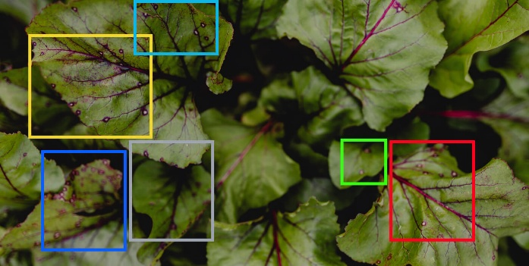

**Fig. 1** **Disease Scanning Image**

Let’s Nurture. (2021). Using deep learning for image-based plant disease detection [Photograph]. Let’s Nurture. <https://www.letsnurture.com/blog/using-deep-learning-for-image-based-plant-disease-detection.html>

# Introduction and Background

## Introduction

***Agriculture is a cornerstone of the global economy, providing food security and livelihoods for billions worldwide.*** However, the sector is increasingly threatened by plant diseases, which can cause substantial reductions in crop yields and disrupt food supply chains (**Li, Zhang, & Wang, 2021**). Early and accurate detection of plant diseases is crucial for mitigating these losses and ensuring sustainable agricultural practices.

**Fig. 2** **Traditional Image recognition processing.**

Reprinted from "Plant Disease Detection and Classification by Deep Learning—A Review," by L. Li, S. Zhang, & B. Wang, 2021, IEEE Access, 9, p. 56685. ©2021 IEEE.

**Traditional plant disease detection methods** rely heavily on manual inspection by agricultural experts. While effective, these approaches are **labor-intensive**, **time-consuming**, and **impractical** for large-scale farming operations (**Mohanty, Hughes, & Salathé, 2016**). Furthermore, these methods are prone to **human error** and often fail to detect diseases in their early stages, leading to **widespread crop damage** before intervention can occur (**Shoaib et al., 2023**).

With the advent of artificial intelligence, **deep learning** has emerged as a transformative tool in the field of agricultural diagnostics. **Convolutional Neural Networks (CNNs)** have demonstrated remarkable success in image classification tasks, making them an ideal choice for **automated plant disease detection** (**Li et al., 2021**). These models can analyze complex patterns in plant leaf images, identifying diseases with high accuracy and enabling early intervention. This research explores the application of deep learning for plant disease detection, evaluating the performance of CNN architectures and proposing an **accessible**, **scalable solution** through a mobile application.

## Background

Historically, plant disease diagnosis has relied on **visual inspection** and **laboratory testing**. While these methods can be effective, they are not scalable **for large agricultural settings** and require significant expertise and resources. The introduction of machine learning provided a more efficient alternative, enabling automated classification of plant diseases based on **engineered features** (**Ahmad, Saraswat, & El Gamal, 2023**). However, traditional machine learning models often struggle with **generalization** due to their dependence on **handcrafted feature extraction** and their limited ability to handle diverse and complex datasets (**Shoaib et al., 2023**).

Deep learning has revolutionized plant disease detection by automating feature extraction and learning **hierarchical patterns** directly from **raw image data**. CNN-based architectures such as AlexNet, VGG, ResNet, and GoogleNet have been widely adopted in **agricultural image analysis**, achieving significant improvements in classification accuracy (**Mohanty et al., 2016**). Despite their success, these models often encounter challenges related to **overfitting**, **high computational requirements**, and **dataset limitations**.

To address these challenges, this research employs three advanced CNN models—**Xception**, **Inception-v3**, and **VGG-19**—leveraging **transfer learning** and **data augmentation** techniques to enhance model robustness. Additionally, **Explainable AI (XAI)** is integrated to improve interpretability, ensuring that predictions are transparent and trustworthy for end-users. Finally, a **mobile application** is developed to provide real-time disease diagnosis, empowering farmers with an accessible and practical tool for early intervention. Also letting them switch between two languages— **Hindi** and **English**, thus targeting the major audience of our country. By bridging the gap between cutting-edge AI technology and real-world agricultural needs, this study aims to contribute to the **advancement of precision agriculture** and **sustainable farming practices.**

**Fig. 3** **Plant Disease Identification Research Timeline**.

Reprinted from "A Survey on Using Deep Learning Techniques for Plant Disease Diagnosis and Recommendations for Development of Appropriate Tools," by A. Ahmad, D. Saraswat, & A. El Gamal, 2023, Smart Agricultural Technology, 3, p. 3. ©2023 Elsevier.

# Related Work

## Research Papers Overview

The use of deep learning for plant disease detection has gained significant attention in recent years, with numerous studies demonstrating its effectiveness in automating the identification of plant diseases through **image-based analysis**. This section discusses key contributions from existing research and identifies the gaps that our study aims to address.

Ahmad et al. (2023) emphasized the need for mobile applications integrated with deep learning for real-time disease detection but focused on reviewing methods rather than implementing a practical solution.

Li et al. (2021) highlighted CNNs' effectiveness and the role of transfer learning in improving model performance while reducing computational costs. However, they noted the lack of interpretability, making it difficult to understand model decisions.

Mohanty et al. (2016) demonstrated that deep learning models outperform traditional machine learning in plant disease classification but relied on a relatively small dataset and did not explore real-world deployment.

Shoaib et al. (2023) compared CNN architectures like AlexNet, ResNet, and GoogleNet, underscoring deep learning’s potential. However, they pointed out the lack of validation on diverse, real-world datasets and called for Explainable AI (XAI) integration to improve model trustworthiness.

## Research Gaps

While existing studies have demonstrated the effectiveness of deep learning in plant disease detection, several challenges remain unaddressed:

### Limited Generalizability:

### Most models are trained and evaluated on curated datasets, lacking validation on real-world agricultural settings.

### Lack of Interpretability:

### Current research highlights the need for Explainable AI (XAI) techniques to improve transparency in model decision-making.

### Real-World Deployment Challenges:

### Despite the high accuracy of CNN models, there is limited focus on developing deployable solutions such as mobile applications.

## Our Contributions

Our study aims to bridge these gaps by:

### Deep Learning Models

### Implementing Xception, Inception-v3, and VGG-19 on a diverse dataset containing 9,112 images across 4 crop species and 14 disease/healthy classes to improve generalizability.

### Explainable AI (XAI)

### Integrating XAI techniques to enhance model interpretability, providing insights into the features influencing predictions.

### Mobile Application with Multi-Language Support

### Developing a mobile application to enable real-time plant disease detection, making deep learning solutions more accessible to farmers. In order to make it more accessible to farmers in our country we’ve developed a feature where users can switch between the English and Hindi interfaces to better understand and use the application without any inconvenience.

By addressing these limitations, our research contributes to the advancement of **precision agriculture**, ensuring a more scalable, interpretable, and deployable deep learning-based solution for plant disease detection.

# Methodology

## Dataset

For this study, we utilized a publicly available dataset sourced from **Kaggle**, consisting of **9,112 images** of plant leaves across **4 crop species** (e.g., Corn, Potato, Rice, and Wheat).

The dataset includes **14 classes**, distinguishing between diseased and healthy leaf images. Each image is labeled with its respective crop species and disease type, making it suitable for a **multi-class classification problem**.

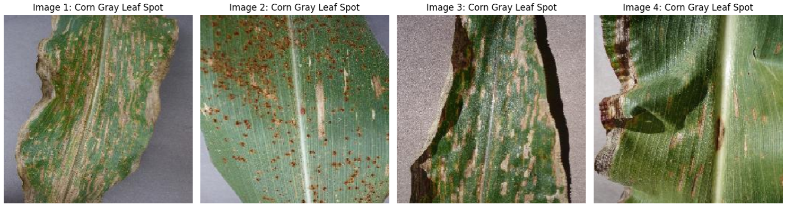

**Fig. 4 Sample Dataset Images**. Self-generated from model.

### A pie chart with text on it AI-generated content may be incorrect.Dataset Distribution

The dataset is split into three subsets:

* Training Set: 70% of the dataset
* Validation Set: 20% of the dataset
* Test Set: 10% of the dataset

### Class Distribution

Each class in the dataset represents a plant disease or a healthy condition. The distribution of images is as follows:

|  |  |
| --- | --- |
| Class Name | Image Count |
| Corn Common Rust | 1,192 |
| Corn Gray Leaf Spot | 513 |
| Corn Healthy | 1,162 |
| Corn Northern Leaf Blight | 985 |
| Potato Early Blight | 1,000 |
| Potato Healthy | 152 |
| Potato Late Blight | 1,000 |
| Rice Brown Spot | 613 |
| Rice Healthy | 1,488 |
| Rice Leaf Blast | 977 |
| Rice Neck Blast | 1,000 |
| Wheat Brown Rust | 902 |
| Wheat Healthy | 1,116 |
| Wheat Yellow Rust | 924 |

| **Table 1. Count of Images for Each Class Fig. 5 Pie Charts Displaying the distribution of images for each class.** Self-generated from model predictions. |
| --- |

The **Imbalance in class distribution** is addressed using **data augmentation** techniques.

## Preprocessing

### Image Resizing

All images are resized to **pre-defined pixels** to match the input requirements of the models.

### Data Augmentation

To improve model generalization and address class imbalance, the following augmentation techniques are applied:

* Random Flipping **(Horizontal)**
* Random Rotation **(up to 20%)**
* Random Zooming **(up to 20%)**
* Random Height and Width Shift **(up to 20%)**

### ****Normalization****

Each image is **normalized** by scaling pixel values to the range **[0,1]**

## Deep Learning Model

In this study, three state-of-the-art deep learning architectures—Xception, Inception-v3, and VGG-19—were employed for plant disease detection. These models were selected based on their superior performance in image classification tasks and their ability to capture intricate patterns in plant leaf images. Each model was trained and fine-tuned using a dataset consisting of **9,112** images spanning **14** classes across **4** crop species.

### Xception

The Xception (Extreme Inception) model, proposed by Chollet (2017), is a convolutional neural network (CNN) that leverages depthwise separable convolutions to enhance computational efficiency while maintaining high accuracy. The model's architecture eliminates traditional convolution layers and replaces them with depthwise separable convolutions, reducing the number of parameters and improving feature extraction.

In our implementation, the Xception model was initialized with pretrained ImageNet weights, and the final layers were fine-tuned for the plant disease classification task. The key modifications include:

* **Input size:** 299 × 299 × 3
* **Base architecture:** Xception (pretrained on ImageNet)
* **Added layers:** Global Average Pooling (GAP), Fully Connected (Dense), SoftMax
* **Optimizer:** Adam (learning rate = 0.0001)
* **Loss function:** Categorical Cross-Entropy
* **Batch size:** 32
* **Epochs:** 11

The model was trained using the TensorFlow framework, and data augmentation techniques such as rotation, flipping, and zooming were applied to improve generalization. The training process was monitored using the validation loss, and early stopping was employed to prevent overfitting.

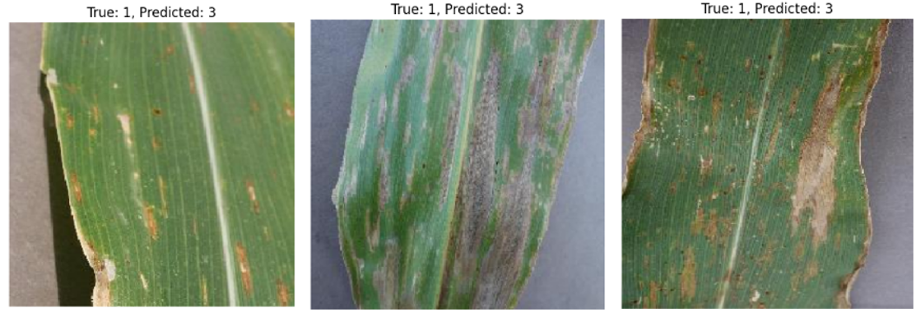

**Fig. 6 Misclassified Images**. Self-generated from model predictions.

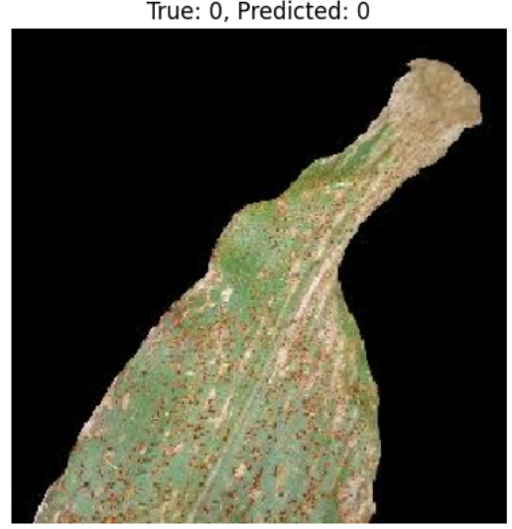

**Fig. 7 Correctly Classified Images.** Self-generated from model predictions.

### Inception-v3

The Inception-v3 model, developed by Szegedy et al. (2016), is an advanced CNN architecture that employs factorized convolutions and auxiliary classifiers to improve feature learning while reducing computational cost. The model consists of multiple Inception modules, which use 1×1, 3×3, and 5×5 convolutions in parallel, enabling multi-scale feature extraction.

For this study, the Inception-v3 model was fine-tuned as follows:

* **Input size:** 228 × 228 × 3
* **Base architecture:** Inception-v3 (pretrained on ImageNet)
* **Added layers:** GAP, Dense, SoftMax
* **Optimizer:** RMSprop (learning rate = 0.0001)
* **Loss function:** Categorical Cross-Entropy
* **Batch size:** 32
* **Epochs:** 8

The model was trained using transfer learning, where the pre-trained base was frozen for the initial epochs, and later, selective layers were unfrozen for fine-tuning. This approach helped retain the robust feature representations learned from ImageNet while adapting the model to the specific plant disease dataset.

### VGG-19

The VGG-19 model, introduced by Simonyan and Zisserman (2014), is a deep CNN architecture comprising 19 layers (16 convolutional + 3 fully connected layers). It follows a simple yet effective design, using small 3×3 convolutional filters stacked sequentially, which enhances feature extraction depth.

In this study, the VGG-19 model was adapted as follows:

* **Input size:** 228 × 228 × 3
* **Base architecture:** VGG-19 (pretrained on ImageNet)
* **Added layers:** GAP, Dense, SoftMax
* **Optimizer:** Adam (learning rate = 0.0001)
* **Loss function:** Categorical Cross-Entropy
* **Batch size:** 32
* **Epochs:** 10

To address the challenge of vanishing gradients, batch normalization was applied, and dropout layers

(rate = 0.5) were introduced to mitigate overfitting. Unlike Inception-v3 and Xception, VGG-19 has a higher parameter count, making it computationally expensive. However, its hierarchical feature learning ability contributes to improved classification accuracy.

Grad-CAM generates a heatmap that highlights critical regions in the input image that influence classification decisions. The following steps were followed to implement Grad-CAM in this study:

### Model Selection & Configuration:

The pre-trained **Xception** model was used, with its last convolutional layer (**block14_sepconv2_act**) identified as the feature extraction layer for Grad-CAM visualization. The final activation function was removed to allow for direct gradient computations.

## Evaluation Metrics

### Accuracy

Measures the percentage of correctly classified images:

### 

### Precision

Measures how many positively classified instances were actually correct:

### Recall (Sensitivity)

Measures the ability of the model to detect diseased leaves:

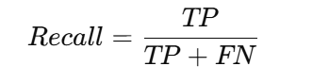

### F1-Score

Harmonic mean of precision and recall:

## Explainability using XAI

Deep learning models for plant disease detection often function as "***black boxes***," making it challenging to interpret their decision-making process. Explainable AI (XAI) techniques, such as **Gradient-weighted Class Activation Mapping (Grad-CAM)**, help visualize which regions in an input image contribute most to the model’s predictions. This enhances transparency and trust in AI-driven agricultural solutions.

### Gradient Computation:

The gradients of the **most** **probable class** were computed with respect to the convolutional feature maps.

### Heatmap Generation:

The computed gradients were averaged spatially to obtain an importance weight for each feature map. These weights were then multiplied with the feature maps and passed through a **ReLU** activation function to retain only positive influences. The heatmap was **normalized** between **0 and 1**.

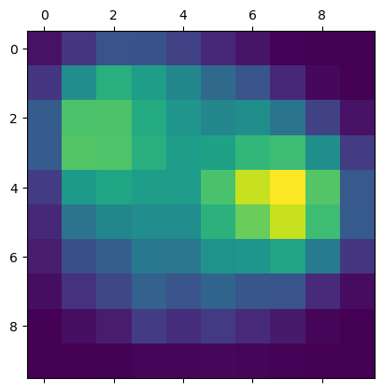

**Fig. 8 Heatmap Visualization for Leaf Disease Detection**. Self-generated from model predictions.

### Superimposition on Original Image:

The generated heatmap was overlaid on the original plant image using a **jet colormap** to create an intuitive visual representation of disease-related regions.

**Fig. 9 Grad-CAM Visualizations for Leaf Disease Detection**. Self-generated from model predictions.

### Results and Interpretation

Grad-CAM visualizations revealed that the model focused primarily on **affected leaf regions** when predicting diseased classes, demonstrating its ability to detect symptoms such as **spots, discoloration, or fungal patches**. For **healthy plant images**, the activation maps were more dispersed, indicating an absence of clear pathological markers.

These findings support the **reliability and interpretability** of deep learning models in plant disease detection. The use of Grad-CAM allows farmers and agricultural experts to understand model predictions better and validate whether the AI is focusing on biologically relevant features.

## Deployment and Mobile App Integration

To make the solution accessible to farmers, we developed a **mobile application (AgroVision)** integrating the trained model for real-time plant disease detection. The app allows users to:

* **Capture or upload an image** of a leaf.
* **Receive instant classification results** with confidence scores.
* **View possible causes and recommended remedies** for the disease.
* **Switch between English and Hindi** for better accessibility.

This mobile-based approach ensures that farmers can **detect diseases early, apply timely interventions, and minimize crop losses**, improving overall agricultural productivity.

## Methodology Overview

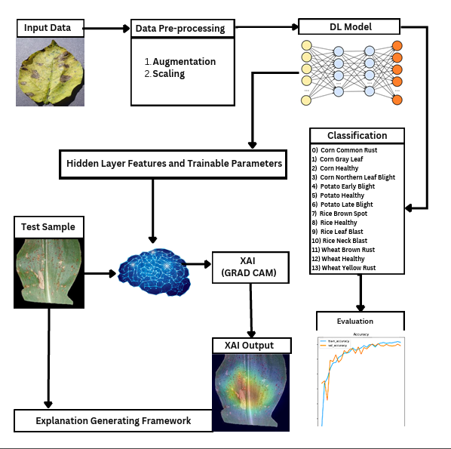

**Fig. 10 Process Flowchart** (SalehAhmedShafin, 2023). Reprinted from "XAI and Deep Neural Networks for Crop Disease Detection and Interpretability," by SalehAhmedShafin, GitHub.

# Results & Discussion

In this section, we present the performance evaluation of the three deep learning models—Xception, Inception-v3, and VGG-19—used for plant disease detection. We analyze their accuracy, precision, recall, and F1-score, and compare the results with prior research. Additionally, we provide accuracy vs. loss graphs and confusion matrices for each model. Based on our findings, we justify the selection of Xception as the final model for our AgroVision app, which integrates deep learning for real-world plant disease detection.

## Performance Metrics

The evaluation metrics for each model are summarized in **Table 1**, which includes accuracy, precision, recall, and F1-score. The results indicate that Xception outperforms Inception-v3 and VGG-19 in all aspects.

|  |  |  |  |  |
| --- | --- | --- | --- | --- |
| Model | Accuracy | Precision | Recall | F1-score |
| Xception | **96%** | 0.95 | 0.96 | 0.95 |
| Inception-v3 | 94% | 0.92 | 0.93 | 0.94 |
| VGG-19 | 87% | 0.87 | 0.86 | 0.87 |

**Table 2. Model Performance Comparison.**

These results highlight that **Xception** achieves the highest accuracy (**96%**), making it the best-suited model for our application.

## Accuracy vs. Loss Graphs & Confusion Matrices

To further analyze model performance, we visualize the **Accuracy vs. Loss Curves** for each model. These plots demonstrate how well the models learned over time and whether they experienced overfitting. The confusion matrices provide insight into the classification performance of each model by displaying the number of correct and incorrect predictions.

**Fig. 11 Xception Model.** Self-generated from model predictions.

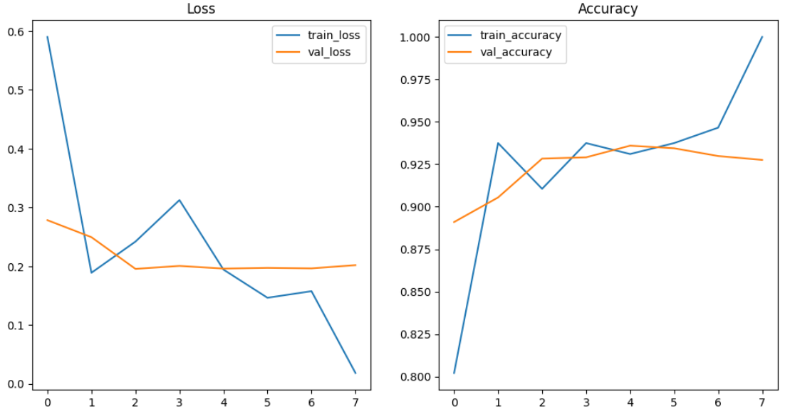

**Fig. 12 Inception-v3.** Self-generated from model predictions.

**Fig. 13 VGG-19.** Self-generated from model predictions.

## Model Selection for AgroVision

Given that **Xception achieves the highest accuracy (96%)**, we selected it as the final model for integration into our **AgroVision** app. The model provides reliable predictions for plant disease detection, ensuring that farmers receive accurate and timely insights about crop health.

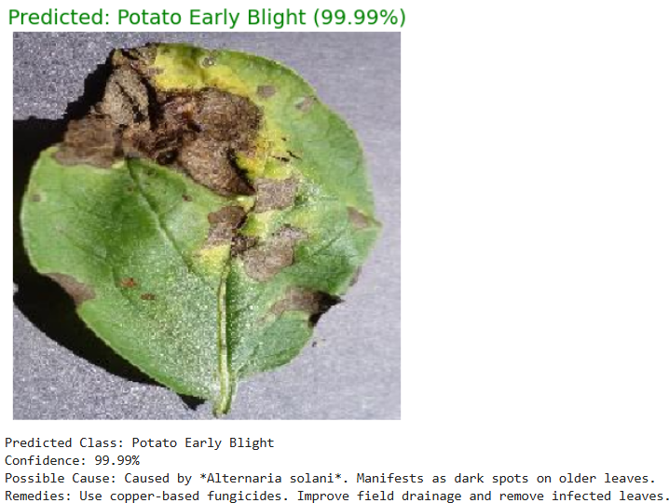



**Fig. 14 Xception Model Prediction with Confidence Level, Causes & Remedies.** Self-generated from the model predictions.

## Explainability with Grad-CAM

To enhance model interpretability, we applied **Gradient-weighted Class Activation Mapping (Grad-CAM)** to visualize the key regions in an image that influenced the model’s predictions. The heatmaps generated by Grad-CAM demonstrate the model’s ability to focus on disease-affected areas in plant leaves, thereby increasing transparency and trust in the predictions.

## App Implementation & Screenshots

The **AgroVision** app incorporates the Xception model for real-time disease detection. The app interface allows users to upload images of plant leaves and receive instant predictions, including the **predicted class, confidence score, possible cause, and recommended remedies**. Since this app was made with the goal of helping farmers, we’ve also implemented a **Multilingual Support** where users can switch to **Hindi** making it more **user-friendly** and **convenient** to use.

App Icon Home Page [English] Capture Image [Camera] Retry or Proceed

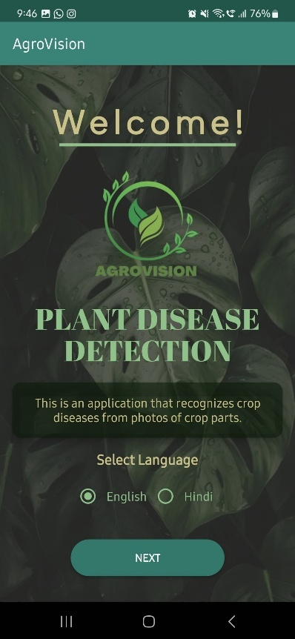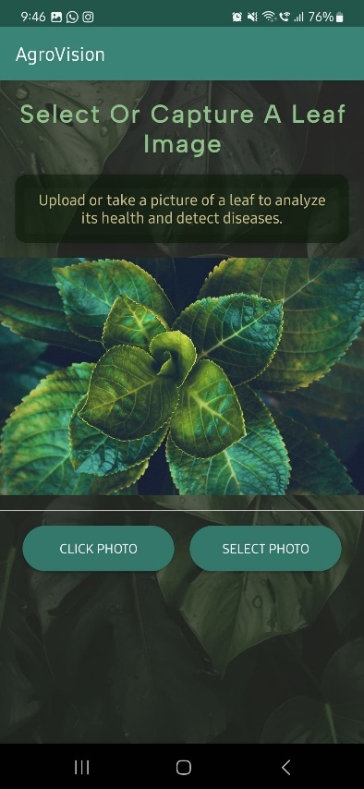

Process Image Results [Diseased Plant] Home Page [Hindi] Select Image [Gallery]

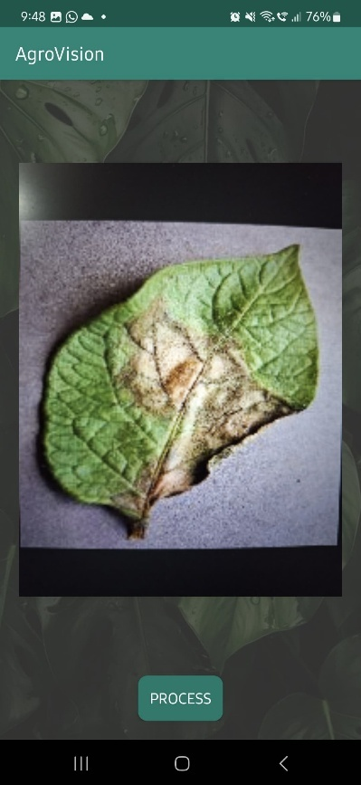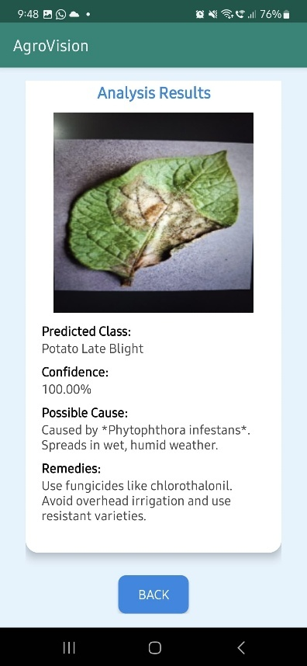

Open Gallery Choose an Image Process Image Results [Healthy Plant]

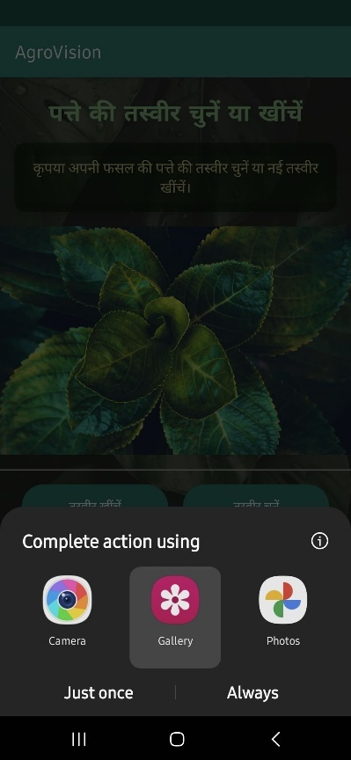

## Comparison with Prior Work

Compared to prior studies on plant disease detection using deep learning ([Li et al., 2021], [Mohanty et al., 2016]), our model demonstrates higher accuracy and improved explainability through Grad-CAM. Moreover, the **real-world implementation in AgroVision** sets it apart by making advanced deep learning models accessible to farmers.

# Conclusion

In summary, **Xception** was chosen as the final model for **AgroVision** due to its superior accuracy and reliability. The integration of **Grad-CAM** further enhances model explainability, ensuring transparency in predictions. By deploying this deep learning-based solution, we bridge the gap between cutting-edge AI research and practical agricultural applications, ultimately contributing to improved crop health monitoring and **sustainable farming practices.**

# Future Work

While the current implementation of **AgroVision** provides accurate disease detection, future improvements can further enhance its capabilities:

* **Expanding the Dataset**: Incorporating more plant species and disease variations to improve generalizability.
* **Model Optimization**: Exploring lighter deep learning architectures for faster inference on mobile devices.
* **Integration of Additional Features**: Adding weather-based disease risk predictions and real-time crop management recommendations.
* **Multilingual Support Enhancement**: Extending language options to reach a broader audience of farmers globally.
* **Edge Computing**: Deploying the model directly on mobile devices to eliminate dependency on cloud-based processing.

These enhancements will further solidify AgroVision as a robust and accessible tool for farmers, empowering them with AI-driven insights to improve agricultural productivity and sustainability.

# 

# Literature References

## Research Paper Citations (APA Format):

* Ahmad, A., Saraswat, D., & El Gamal, A. (2023). A survey on using deep learning techniques for plant disease diagnosis and recommendations for development of appropriate tools. Smart Agricultural Technology, 3, 100083.
* Li, L., Zhang, S., & Wang, B. (2021). Plant disease detection and classification by deep learning—a review. IEEE Access, 9, 56683-56698.
* Mohanty, S. P., Hughes, D. P., & Salathé, M. (2016). Using deep learning for image-based plant disease detection. Frontiers in plant science, 7, 1419.
* Shoaib, M., Shah, B., Ei-Sappagh, S., Ali, A., Ullah, A., Alenezi, F., ... & Ali, F. (2023). An advanced deep learning models-based plant disease detection: A review of recent research. Frontiers in Plant Science, 14, 1158933.

## Articles and Journals:

* <https://www.nature.com/articles/s41598-023-34549-2>
* <https://www.sciencedirect.com/science/article/pii/S2666154323002715>

## GitHub Links:

* <https://github.com/vermasrijan/PlantDiseaseDetectionApp>
* <https://github.com/SalehAhmedShafin/XAI-and-Deep-Neural-Networks-for-Crop-Disease-Detection-and-Interpretability>
* <https://github.com/MarkoArsenovic/DeepLearning_PlantDiseases/tree/master>
* <https://github.com/Shubham-Jain-09/Crop-Disease-Detection/tree/master>